Lab 8: MongoDB Authentication Using Docker
Student: Sandesh Khatiwada

OBJECTIVES:
1. Understand MongoDB authentication mechanism
2. Run MongoDB with authentication enabled using Docker
3. Verify authorized and unauthorized access to databases
4. Create and access collections securely

- CREATE DIRECTORY STRUCTURE
- Create main directory for MongoDB authentication
mkdir "D:\Practical\8th Sem\Mogo_auth"
- Navigate to the directory
cd "D:\Practical\8th Sem\Mogo_auth"
- Create data directory for MongoDB persistence
mkdir data
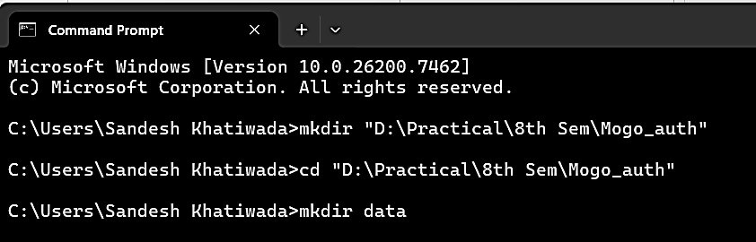

- Run MongoDB container with authentication enabled
docker run -d --name mongo_auth -p 27017:27017 -v "D:\Practical\8th Sem\Mogo_auth\data:/data/db" mongo:8.0 –auth
- Verify Mongodb container status
docker ps
- Connect Mongodb shell without authentication
- Access MongoDB shell
docker exec -it mongo_auth mongosh
- Attempt to view collections (expected to fail)
show collections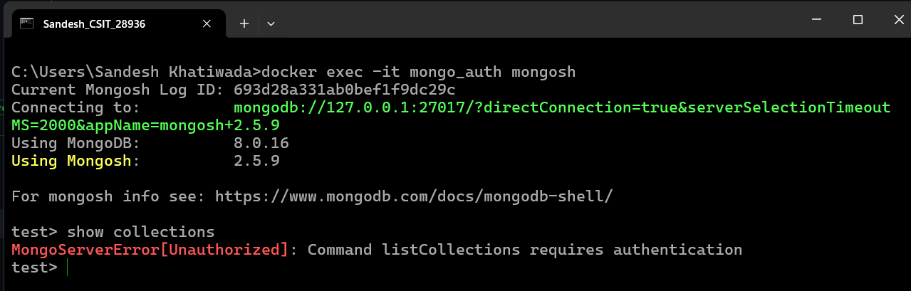
- Switch to admin
- Switch to admin database
use admin
- Authenticate user
db.auth("sandesh", "sandesh")
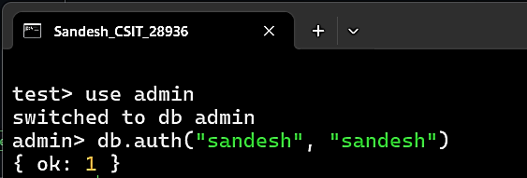
- Verify authenticated access
- Verify collections access
show collections
- Switch to application database
use oic
- Create students collection
db.createCollection("students"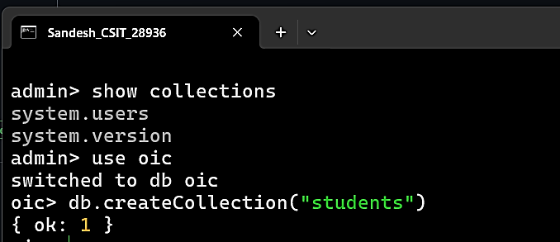

- Verify the students collection and test queries
- Verify collection
show collections
- Insert a document
db.students.insertOne(
{ name: "Sandesh", roll: 28936, subject: "MongoDB Security"}
)
- Fetch documents
db.students.find()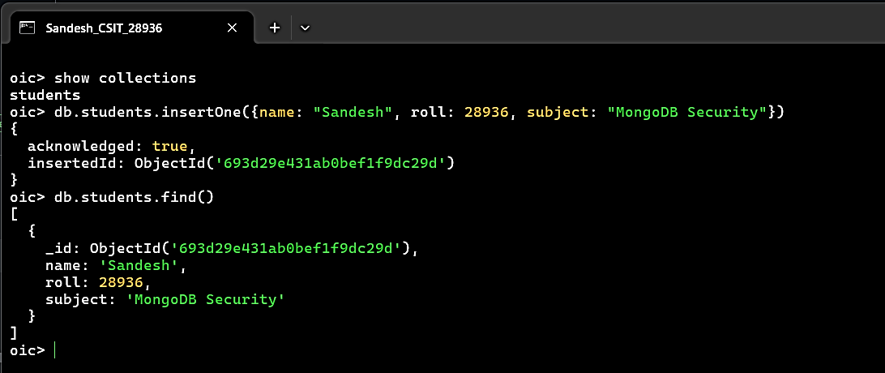

- Test unauthorized access (demonstrate security)
- Exit MongoDB shell
exit

- Reconnect without authentication
docker exec -it mongo_auth mongosh

- Attempt unauthorized access
use oic
show collections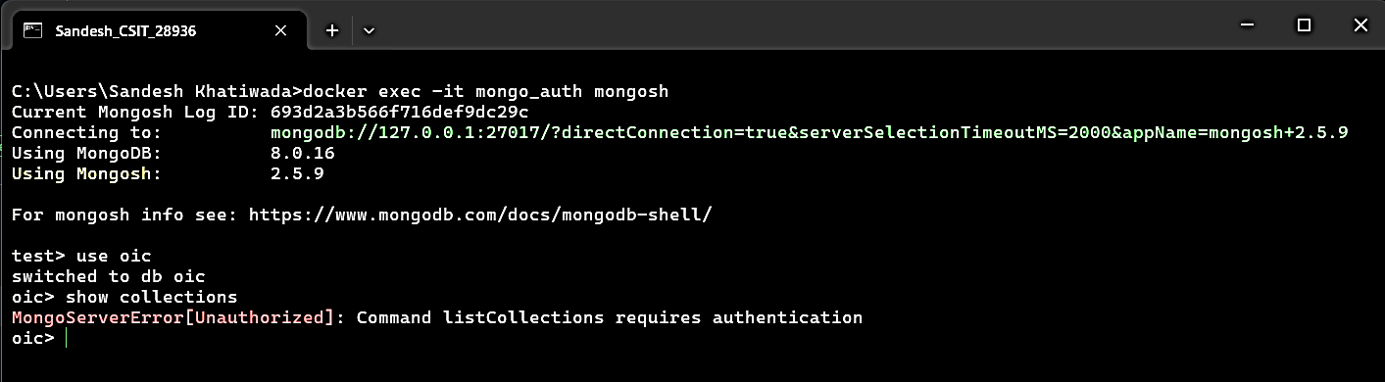

Conclusion:
MongoDB authentication was successfully implemented using Docker.
Authorized users were able to access and manipulate data,
while unauthorized access was correctly restricted.
This lab demonstrates basic MongoDB security enforcement
and the importance of authentication in database systems.

